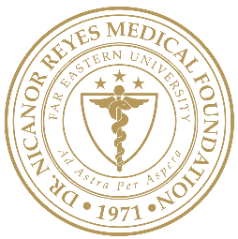 | Far Eastern University  NICANOR REYES MEDICAL FOUNDATION  Institutional Ethics Review Committee | DOCUMENT CODE:
 |  | EFFECTIVE DATE:
 | DOCUMENT TITLE: | REV. NO.:
 |  | PAGE: n of N

Document History
Author | Version | Date | Description of main change
Name |  | mm-dd-yyyy | First draft  Second draft  Final version  Minor changes  Major changes  No change (routine review)
Name |  | mm-dd-yyyy
Name |  | mm-dd-yyyy
Name |  | mm-dd-yyyy
Name |  | mm-dd-yyyy
Name |  | mm-dd-yyyy

