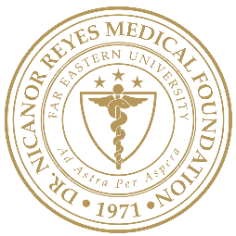 | Far Eastern University  NICANOR REYES MEDICAL FOUNDATION  Institutional Ethics Review Committee | DOCUMENT CODE:
 |  | EFFECTIVE DATE:
 | DOCUMENT TITLE: | REV. NO.:
 |  | PAGE: n of N

Standard Operating Procedures
Content 1
Content 2
Content 3

Supersedes | <version number>
Version: | <version number>
Authored by: | <TITLE, NAME, SURNAME>
Version Date: | mm/dd/yyyy
Approved by: | President  Far Eastern University - Dr. Nicanor Reyes Medical Foundation
Approval Date: | mm/dd/yyyy

FAR EASTERN UNIVERSITY – NICANOR REYES MEDICAL FOUNDATION
INSTITUTIONAL ETHICS REVIEW COMMITTEE
Rm 218, 2nd Floor, Institute of Medicine
Regalado Avenue near Dahlia Street, West Fairview, Quezon City 1118
Telefax: +63 (02) 8-9838338 loc 1236; Email: ierc@feu-nrmf.edu.ph

