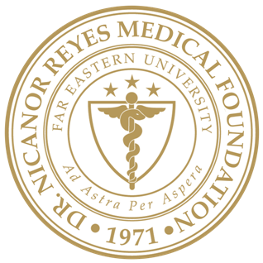 | Far Eastern University – Dr. Nicanor Reyes Medical Foundation  INSTITUTIONAL ETHICS REVIEW COMMITTEE  Rm 218, 2nd Floor, Institute of Medicine  Regalado Avenue near Dahlia Street, West Fairview, Quezon City 1118  Telefax: +63 (02) 8-9838338 loc 1236; Email: ierc@feu-nrmf.edu.ph
<mm/dd/yyyy>
<NAME OF PI>
Principal Investigator
<Institution/Affiliation>
<Address>
Re: | <FEU-NRMF IERC Code>
 | <Study Protocol Title>
Dear <TITLE OF PI><SURNAME>:
We wish to inform you that the FAR EASTERN UNIVERSITY-DR. NICANOR REYES MEDICAL FOUNDATION INSTITUTIONAL ETHICS REVIEW COMMITTEE (FEU-NRMF IERC) reviewed your submission/resubmission/proposed amendments during its regular meeting <date of meeting> and is requesting further clarification. Your study has been assigned study protocol code <FEU-NRMF IERC Code>, which should be used for all communication to the FEU-NRMF IERC related to this study.
As a result of the<FULL BOARD/EXPEDITED> review, committee action is MAJOR MODIFICATIONS PRIOR TO APPROVAL/MINORMODIFICATIONS PRIOR TO APPROVAL. Recommended revisions and/or clarifications are summarized below:

Please note that revisions requested by the FEU-NRMF IERC should:
- Be integrated into a revised STUDY PROTOCOL/PACKAGE and <FEU-NRMF IERC FORM2(B)2022: APPLICATION FORM/FEU-NRMF IERC FORM3(A)2022: STUDY PROTOCOL AMENDMENT SUBMISSION FORM>, and related documents in<number of copies in words> (<number of copies in numerical form>) printed copies and one (1) electronic copy.
- Be SUMMARIZED in a cover letter indicating in which page of the revised study protocol the respective revision may be found;
- Modified part should be underlined and bold; and
- Include a footer (in all pages) that indicates both the DATE and VERSION NUMBER of the resubmitted study protocol.
Please note that the cut-off date for submission of revised study protocol is on<Date>. Also, please note that resubmissions can only be accepted within 90 days from the date of this letter. Failure to respond within 90 days from the date of this letter will inactivate the application and study protocol will be archived. Subsequent submissions will be processed as initial review. Should you have any questions or clarifications regarding the abovementioned recommendations, please contact the undersigned through the FEU-NRMF IERC Secretariat at +63 (02) 8-9838338 loc. 1236.
The FEU-NRMF IERC looks forward to your immediate response and action.
Very truly yours,

<NAME OF FEU-NRMF IERC CHAIR>
Chair, FEU-NRMF IERC

