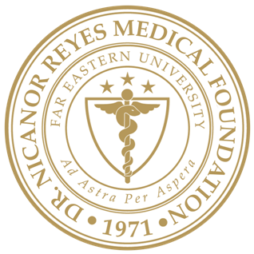 | Far Eastern University – Dr. Nicanor Reyes Medical Foundation  INSTITUTIONAL ETHICS REVIEW COMMITTEE  Rm 218, 2nd Floor, Institute of Medicine  Regalado Avenue near Dahlia Street, West Fairview, Quezon City 1118  Telefax: +63 (02) 8-9838338 loc 1236; Email: ierc@feu-nrmf.edu.ph
<mm/dd/yyyy>
<TITLE, NAME, SURNAME OF CHAIR>
Chair
FEU-NRMF Institutional Ethics Review Committee

Re: | <Study Protocol Title>
Dear <TITLE OF Chair> <SURNAME>:
I am requesting a waiver of written and verbal informed consent. I believe that this protocol is eligible for waiver or alteration of all required elements of informed consent because the protocol meets all of the following criteria:
- The risk to subject’s privacy is minimal.
The investigator of this study will use the minimum amount of protected health information necessary to conduct the research. This study will only need charts of eligible subjects. There is an assurance written below that the protected health information will not be reused or disclosed to any other person or identity, except as required by law, for authorized oversight of the research study, or for the research for which the use or disclosure or protected health information would be permitted by the Data Privacy Act of 2012.
- This research cannot be practicably conducted without the waiver.
  - The number of research subjects proposed
  - Difficulty of obtaining individual authorization and time since last contact with research subjects.
RESEARCH ASSURANCES:
As principal investigator of the research described above, I make the following assurance to the FEU-NRMF Institutional Ethics Review Committee regarding the use and disclosure of protected health information.
“The researcher and research staff who used the disclosed protected health information in connection with this research will not reuse the protected health information or disclose to any other person or entity other than those authorized to receive it, except:
- As required by law,
- For authorized oversight of the research study, or
- For other research which the use of disclosure of protected health information would be permitted by the Data Privacy Act of 2012.
Thank you.
Very truly yours,
<NAME OF PRINCIPAL INVESTIGATOR>
Principal Investigator

